**KPI 4 Insights (State wise and month wise loan status)**

* Our loan data shows that December had the highest loan activity. In December, the total loan amount disbursed was $42 million (Fully Paid), with $9 million charged off and $4 million currently paid.
* Conversely, February had the lowest overall loan activity. While the fully paid amount in February ($22 million) was similar to January, the charged off amount in February was significantly lower at $3 million.
* Analysing loan data by state reveals California (CA) as the leading consumer with the following breakdown:
* Fully Paid Loans: $64 million
* Charged Off Loans: $14 million
* Currently Paying Loans: $2 million
* Maine (ME) exhibits the lowest loan consumption at $9.2k(Fully Paid).

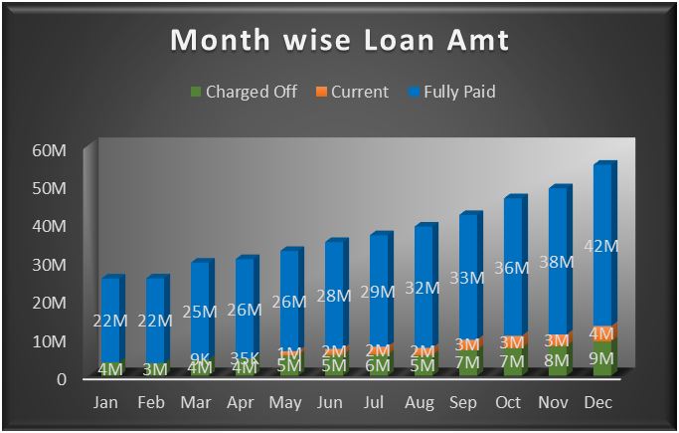

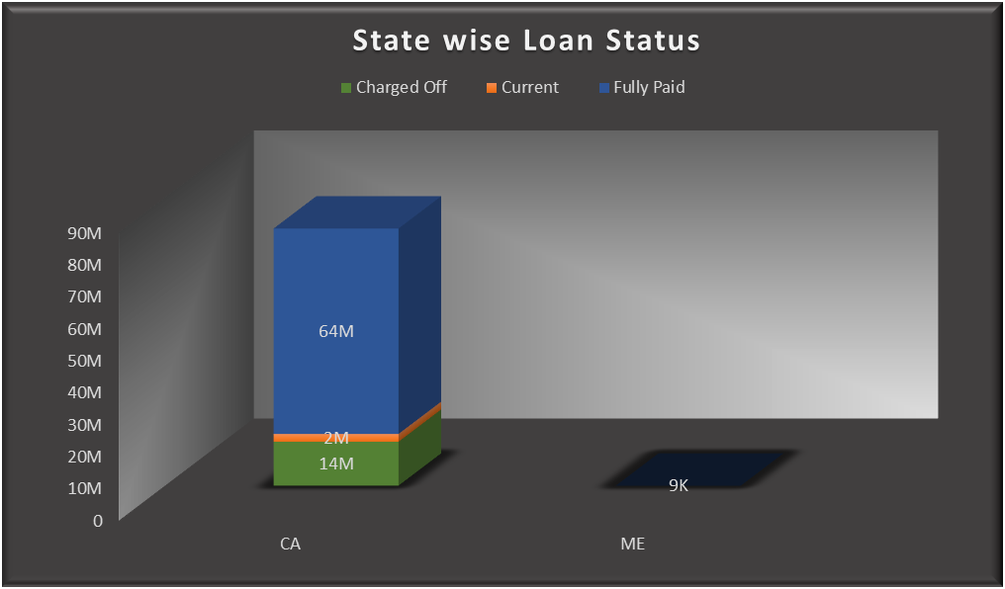

**KPI 5 Insights(Home ownership Vs last payment date)**